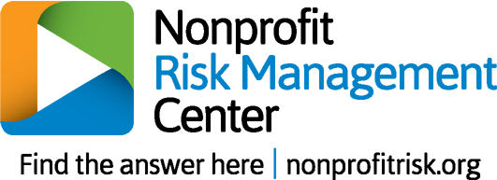
Light-Touch Risk Categorization
This risk frame consists of two approaches:
- altering your trajectory to avoid the risk, and
- managing through unavoidable circumstances.
Teams should strive to strike a balanced portfolio between these two strategies.
Gather your risk team and begin categorizing your top risks into these two approaches. Brainstorm a few actions that will help mitigate downside effects or fortify your organization in the face of the situations. The final page offers space to document risks that require actions in both categories.
Alter Your Trajectory | Ready for Reality
Risk Event: | Risk Event:
- Action 1  - Action 2  - Action 3 | - Action 1  - Action 2  - Action 3
Risk Event: | Risk Event:
- Action 1  - Action 2  - Action 3 | - Action 1  - Action 2  - Action 3

Alter Your Trajectory | Ready for Reality
Risk Event: | Risk Event:
- Action 1  - Action 2  - Action 3 | - Action 1  - Action 2  - Action 3
Risk Event: | Risk Event:
- Action 1  - Action 2  - Action 3 | - Action 1  - Action 2  - Action 3
Risk Event: | Risk Event:
- Action 1  - Action 2  - Action 3 | - Action 1  - Action 2  - Action 3

The risk events below warrant action in both areas: avoiding the risk and getting ready to manage through it.

Alter Your Trajectory | Ready for Reality
Risk Event:

- Action 1  - Action 2  - Action 3 | - Action 1  - Action 2  - Action 3
Risk Event:

- Action 1  - Action 2  - Action 3 | - Action 1  - Action 2  - Action 3
Risk Event:

- Action 1  - Action 2  - Action 3 | - Action 1  - Action 2  - Action 3

