The Ladder of Inference Workshop Facilitation Guide

Affiliate Member Webinar

Erin Gloeckner, Project Manager
Nonprofit Risk Management Center
Erin@nonprofitrisk.org | 703.777.3504

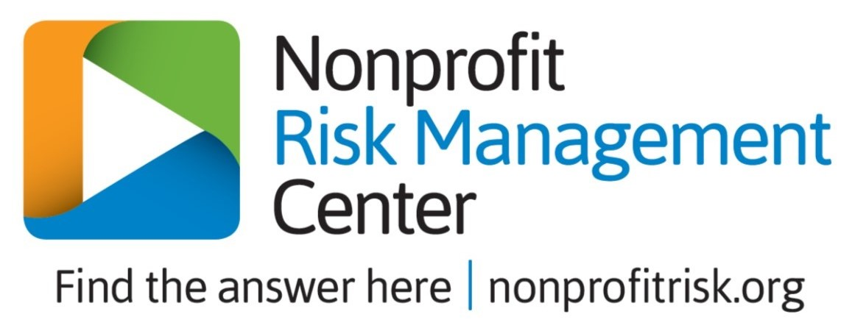
The Ladder of Inference: Workshop Facilitation Guide

Step #1: Watch ‘The Ladder of Inference’ webinar in the webinar vault to learn detailed facilitation instructions.

Step #2: Understand how this workshop is structured.
- This workshop requires you to present conceptual content in small chunks, between facilitating activities for your team members. These hands-on activities allow your team to practice applying the new concepts that you introduce throughout the workshop.
- This workshop also requires you to break your team into small groups. Try breaking your team into 4 (or fewer) small groups. This guide provides handout materials that are suitable for 4 or fewer small groups.
- During the workshop, you will present 3 risk scenarios that your small groups will work through. If you want, you can ask a few members of each group to rotate after each scenario. By responding to the scenarios with different team members, your participants will have the chance to collaborate with members of the whole team while being exposed to diverse ideas.

Step #3: Prepare your materials.
- Provide pens/pencils and paper/sticky notes for your participants.
- Print the following materials; these materials are all included in this handout:
  - 4+ copies of the ‘Ladder of Inference Image.’ We suggest placing these at the tables where your 4 small groups are seated.
  - 4+ copies of each of the 3 Ladder scenarios. We suggest passing these handouts out during the workshop as a reference. Do not pass the paper scenarios out until you begin discussing each scenario during the workshop!
  - 1 copy of each of the ‘New Facts!’ worksheets (3 worksheets total). Cut up the ‘New Facts’ worksheets so that you can pass out a unique fact for each small group. We created 4 new facts for each scenario, so try to break your team up into 4 small groups for this workshop. Do not pass out the new facts until your small groups have discussed the related scenario during the workshop! See instructions below for more info.

Step #4: Present the workshop!
- First, ask your team to split into 4 (or fewer) small groups (see step #2 above).

- To begin, you can reference the common ‘mental mistakes’ in risk practice, which we discuss at the beginning of the recorded webinar. These concepts can help you relate the Ladder of Inference concept to risk management more clearly.
  - Mistake #1: faulty assumptions
  - Mistake #2: choosing beliefs over evidence
  - Mistake #3: the rush to judgment
  - Mistake #4: superficial learning from loss

- Next, you will explain the ladder of inference concept and a real-life example. Try using this great TED video, which is referenced in the recorded webinar. TED Video: https://www.youtube.com/watch?v=KJLqOclPqis

- Next, you will ask your team to practice applying the Ladder of Inference concept by exploring 3 risk scenarios. Your team will work through the scenarios one at a time, and you will provide more information between each of the scenarios.

- To present the SCENARIOS:
  - Share each individual scenario in a PPT and orally. Sharing the info through multiple channels will accommodate teammates who have different learning styles.
  - After you share a scenario, ask everyone in the room to write down a gut reaction: ‘How would YOU address this situation? Write down your gut reaction… the first action step that comes to your mind.’ By asking your team members to write their reactions down, you are providing a comfortable way for introverted participants to express their responses.
  - Next, ask participants to share their reactions within their small groups. Ask each small group to agree upon ONE reaction or action step.
  - Next, provide each small group with a unique ‘NEW FACT’ that is related to the scenario at hand. Allow the small groups to read the new fact on paper, so that other groups can’t overhear.
  - Now bring up some discussion questions for the small groups to reflect on. You could display these on a PPT. The discussion questions are provided later in this handout.
  - After small groups discuss their new facts, ask each group to report back to the whole team. Suggested discussion questions are provided in this handout.

- After each scenario, you will present a mini-lecture, during which you give a little more advice to your team. Ask your team to apply this new advice as they work through each upcoming Ladder scenario. An outline for your mini-lectures is provided below, and you can find detailed information in the recorded webinar.

  - After Scenario #1: discuss Ladder pitfalls such as:
    - How the ladder occurs quickly and subconsciously
    - How each person’s ladder is invisible to everyone else
    - How the ladder creates a reflexive loop (reinforcement)
    - How the Assumption Rung may be the most dangerous rung of the ladder. Share a few examples of common assumptions or biases (e.g., Anchoring bias, confirmation bias, etc.).

  - After Scenario #2: offer advice for effectively climbing the Ladder with peers such as your coworkers.
    - How to practice productive inquiry and productive advocacy
    - How to remain open to re-circuiting your Ladder
    - How to identify ‘skilled incompetence’
    - How to convert the abstract to the concrete
    - How to recognize that admitting you are wrong is a good thing!

  - After Scenario #3: facilitate a closing discussion. Ask your team questions like:
    - How can this apply to our professional and/or personal lives?
    - How can we actively try to re-circuit our ladders at work?
    - How do you think the Ladder of Inference can be used as a risk management technique?
    - What is ONE THING you learned during this workshop that you want to apply at work? (you can ask participants to write down their ‘ONE THING’ and refer to it at a later date as a reminder)

Ladder of Inference Image
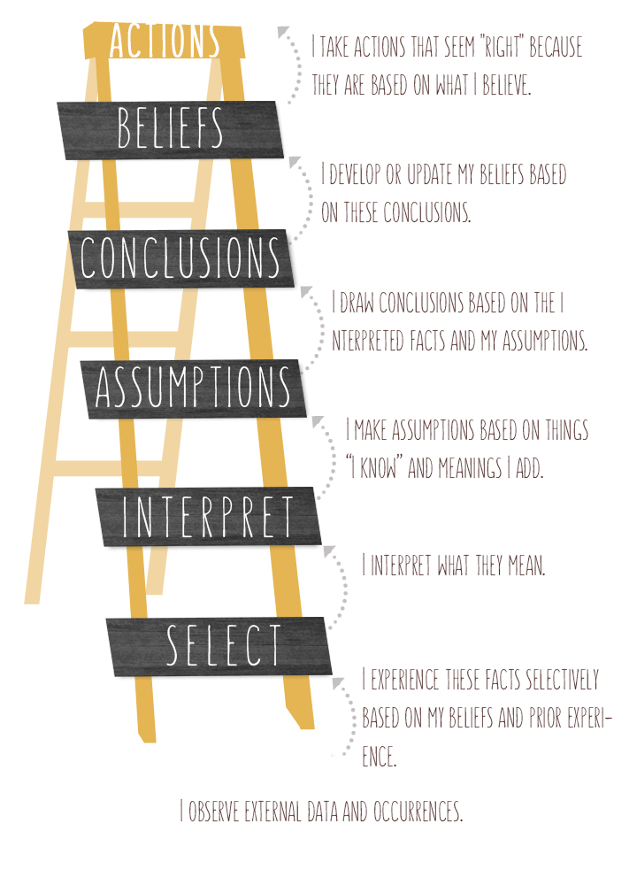
Image Source: Leadership Network (http://leadnet.org/the-7-deadly-assumptions/)

Scenario #1: Child Safety

Scenario:
You are the Child Safety Director of a national youth-serving nonprofit that operates daycare centers for children with developmental disabilities. Your job is to ensure that your nonprofit adheres to best-in-class youth protection policies and practices in order to keep your young participants safe and happy.

One of your policies states that daycare workers are not allowed to carry their personal phones while at work. They must leave personal phones in the employee locker rooms. This policy exists to prevent employees from taking inappropriate photos of children. If any employee witnesses another employee breaking this rule, he or she must report the misconduct so that you can address it.

After a weeklong vacation, you return to work and learn that 5 reports have been made at a single daycare facility. What would you do?

Scenario #1: Child Safety
NEW FACTS!

Team #1: You learn that the same employee has submitted all five reports of misconduct.

Team #2: You learn that your daycare manager has been using her phone on the job in front of her subordinates.

Team #3: You learn that your daycare employees are rarely offered personal breaks during their 8-hour shifts.

Team #4: You learn that a grassroots fundraiser for disabled children has caught on like wildfire. It asks donors and fans to use Twitter to post photos of the most inspiring children they know.

Scenario #1: Child Safety
Discussion Questions

*Put these discussion questions on a PPT and present them during scenario #1 after you provide the ‘new facts’ to each small group. Ask the small groups to discuss these questions.

- Is your course of action still valid now that you have this new fact?
  - If not, which rung of the Ladder caused you to veer off course?
- What real data can you work with in this scenario?
- What assumptions did you make?
- What is a more appropriate course of action (considering the new fact your group received)?
- Did anyone on your team initially suggest a better course of action?

After you give the small groups time to discuss the questions above, ask a member of each group to report back to the whole team. They can report information such as:

- What was your group’s new fact?
- How did your response change?
- Where did you get stuck on the Ladder?
Scenario #2: Coworker Conflict

Scenario:
You are the Risk Manager of a national association for deep-sea divers. Your organization hosts marine excursions and sells discount diving equipment. Part of your job is to ensure that your members can dive safely, so you offer safety training and incident investigation services.

Each quarter, you produce risk reports on recent diving incidents, and you recommend changes (as necessary) in diving practice and safety training. Your colleagues in the equipment and excursions departments are expected to review your reports and offer feedback, as well as help implement any recommendations that are put into practice.

After you deliver a particularly juicy risk report, you feel that the management team is distant and unwilling to provide a response. A sales associate from the excursions department tells you that Jim, the head of the excursions department, hates your reports because your safety regulations could interfere with his sales.

Scenario #2: Coworker Conflict
NEW FACTS!

Team #1: You learn that your informant was recently passed up for a promotion by Jim (his supervisor).

Team #2: You learn that your last safety policy caused Jim’s department to lose $15,000 on diving gear that he purchased just before the announcement of your new specifications.

Team #3: You learn that your CFO is putting immense pressure on Jim to forgo safety regulations in order to produce sales.

Team #4: You are confronted by Jim, who heard a rumor that you hate his sales team because they ‘don’t give a crap about safety.’

Scenario #2: Coworker Conflict
Discussion Questions

*Put these discussion questions on a PPT and present them during scenario #2 after you provide the ‘new facts’ to each small group. Ask the small groups to discuss these questions.

- Is your course of action still valid now that you have this new fact?
  - If not, what led you to change your course of action? (e.g., identifying new data, recognizing false assumptions, etc.)
  - What is a more appropriate course of action?

- Did you fall victim to any Ladder pitfalls?
  - Quick judgment
  - Failing to share your Ladder with your team
  - Making decisions based on your own reinforced/existing attitudes

- Did you do better this time? (compared to scenario #1)

After you give the small groups time to discuss the questions above, ask a member of each group to report back to the whole team. They can report information such as:

- What was your group’s new fact?
- How did your response change?
- Was your experience better this time?

Scenario #3: Gala Fiasco

Scenario:
You are the CEO of a high-profile foundation that supports AIDS awareness campaigns, AIDS prevention and treatment programs, and other advocacy projects. Each year, you host a gala that attracts hundreds of wealthy and highly engaged donors. The gala is a high-pressure event in which you are expected to put on a great show and rake in the money.

At this year’s gala, you introduce a new board member who has actively participated in AIDS prevention work throughout his life. Having him on the board will draw tons of public attention and donations to your foundation. The introduction goes well—after finishing your presentation, you return to your guests who continue to mingle and enjoy themselves.

Later on, across the room, you hear a commotion and see your new board member acting aggressively toward an event volunteer. Your board member shouts angrily, ‘None of this will ever make a difference!’ The entire gala goes silent as all the guests stare in shock. A few guests videotape the scene on their phones, and quickly post the videos on social media. Your team immediately begins getting tweets and Facebook comments from concerned supporters, and then calls start coming in from national news agencies.

Scenario #3: Gala Fiasco
NEW FACTS!

Team #1: You learn that the volunteer was drinking during the event. He taunted your board member about ‘selling out’ and giving up his work to schmooze shallow donors.

Team #2: You learn that your board member’s brother was diagnosed with AIDS the day before the gala.

Team #3: You learn that the board member has a history of violent outbursts. You realize this board member was not properly screened since a close friend had recommended him to you.

Team #4: You are confronted by the upset board member who wants to quit. He says that the board didn’t explain his role clearly. He never expected to ‘schmooze shallow donors who know nothing about the challenges of living with AIDS.’

Scenario #3: Gala Fiasco
Discussion Questions

*Put these discussion questions on a PPT and present them during scenario #3 after you provide the ‘new facts’ to each small group. Ask the small groups to discuss these questions.

- Is your course of action still valid now that you have this new fact?
  - What is a more appropriate course of action?

- How well did you climb the Ladder with your team? How did you use climbing skills such as…?
  - Productive inquiry
  - Productive advocacy
  - Turning off autopilot
  - Focusing on the concrete
  - Being okay with being wrong!

After you give the small groups time to discuss the questions above, ask a member of each group to report back to the whole team. They can report information such as:

- What was your group’s new fact?
- How did your response change?
- What was the best technique you used to climb the Ladder together?

