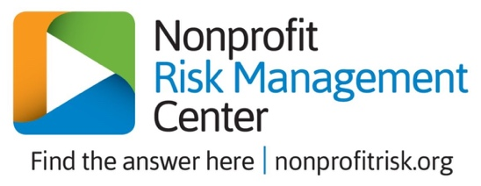

Managing Risk and Reward in a Multigenerational Workforce
Affiliate Member Webinar
Wednesday, February 13 | 2:00 pm Eastern

2017 Thought Leaders Solutions Forum: Harnessing the Power of a Multigeneration Workforce
www.shrm.org/foundation/ourwork/initiatives/the-aging-workforce/Lists/Curated%20source%20for%20page%20The%20Aging%20Workforce/Attachments/17/2017%20TL%20Executive%20Summary-FINAL.pdf

“7 Proven Ways to Build a More Inclusive Workplace,” - www.deettajones.com/7-proven-ways-more-inclusive-workplace/

“7 Things We Learned From Deloitte’s “Meet the Modern Learner,” – www.blog.grovo.com/7-learned-deloittes-meet-modern-learner/

“Generation Z Is About to hit DC. Here’s What Employers Need to Know,”
www.washingtonian.com/2019/01/17/generation-z-is-about-to-hit-dc-heres-what-employers-need-to-know/

How to Create a More Inclusive Workplace - www.adventuretravelnews.com/how-to-create-a-more-inclusive-workplace

Managing an Age-Diverse Workforce: What Employers Need to Know, CIPD
www.cipd.co.uk/knowledge/fundamentals/relations/diversity/age-diversity-insights-report

“The Challenges of Managing a Multi-Generational Workforce”
www.bloomberg.com/diversity-inclusion/blog/challenges-managing-multi-generational-workforce/

“Three Common Multi-Generational Workplace Problems (and How to Solve Them)”
www.kellyservices.us/us/business_services/business-resource-center/managing-employees/three-common-multi-generational-workplace-problems-and-how-to-solve-them/

“Why a Multigenerational Workforce is a Competitive Advantage”
www.forbes.com/sites/wesgay/2017/10/20/multigeneration-workforce/#3feec5754bfd

Multi- Generational Workforce Articles Written by the Nonprofit Risk Management Center

“5 Musts to Attract Mission-Motivated Millennials”
www.nonprofitrisk.org/resources/e-news/5-musts/

“Avoid World War Y”
www.nonprofitrisk.org/resources/e-news/avoid-world-war-y/

“My Generation: Reaping the Rewards of a Multigenerational Workforce”
www.nonprofitrisk.org/resources/articles/my-generation-reaping-the-rewards-of-a-multigenerational-workforce/

“Why Can’t We All Get Along? Managing a Multi-Generational Workforce?
www.nonprofitrisk.org/resources/webinars/why-cant-we-all-get-along-managing-a-multi-generational-workforce/

