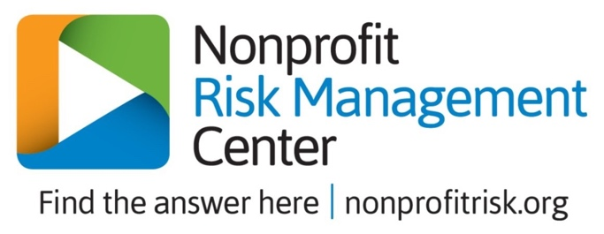
SAMPLE BOARD CODE OF CONDUCT
Code of Conduct

As a member of the nonprofit Board I will…
- Listen carefully to my fellow board members
- Respect the opinions of other board members
- Respect and support the decisions of the board, including in instances where I voted against a particular decision/action
- Recognize that all authority is vested in the board as a whole and not with individual board members
- Keep informed of developments that are relevant to issues that may come before the board
- Participate actively in board meetings and come to meetings with an open mind and sincere interest in learning about the issues before the board and engaging in dialogue with my fellow board members
- Call to the attention of the board any issues that I believe will have an adverse or beneficial impact on the nonprofit’s mission and programs
- Refer complaints from stakeholders of the nonprofit to the appropriate persons in the chain of command
- Represent all of the nonprofit’s stakeholders and not a particular special interest group
- Consider myself a trustee of the nonprofit and do my best to ensure that the nonprofit is financially secure and healthy and always operating in pursuit of its mission

As a member of the nonprofit Board I will not…
- Be critical, in or outside of a board meeting, of other board members or their opinions. This does not restrict me from respectfully disagreeing with another board member
- Use the nonprofit or its assets for my personal advantage, or the personal advantage or benefit of my friends or relatives
- Discuss the confidential proceedings of the board outside a board or committee meeting
- Promise—prior to a board meeting—how I will vote on any issue being brought before the board
- Interfere with the duties of the Executive Director or undermine the authority of the Executive Director

- I have read and agree to abide by this Code of Conduct during my term of service on the board. Signature __________________________________________ Date ___________________

